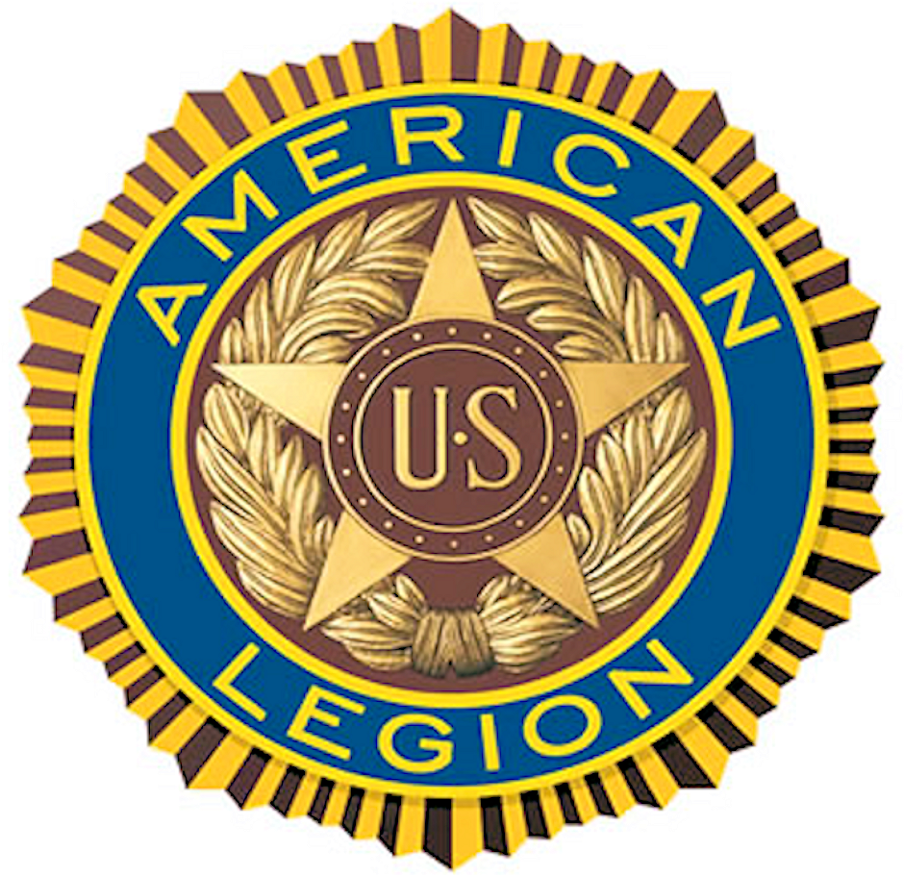
Post 283
Handbook

RONALD REAGAN-PALISADES
15247 La Cruz Drive
Pacific Palisades, CA 90272
Table of Contents

Our Post: 3
Post Meetings 3
A Short History 4
Legion Uniform 4
Legion Language and Protocols 5
Volunteers are Super! They are! 5
Training: 6
“This is The American Legion” 6
Basic Training 6
Legion College 6
Legion Publications - 6
Member Information (MyLegion.org) 7
Post Governance: 8
Executive Committee 8
Vision of Success: 8
Key Post Goals: 8
Mission Statement: 8
Constitution & By-Laws: 8
Post Leadership: 9
No Partisan Politics 9
Summary Post Leader Duties 9
Post Operating Committees: 11
Committee Descriptions 11
The Preamble: 13
Our Post Address 13

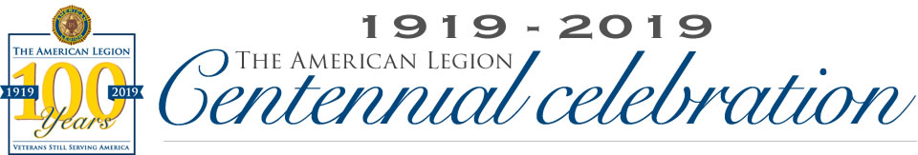

Our Post
Welcome and Congratulations on your membership in The American Legion and Our Post. You now belong to our Legion family of over 4 million members! The American Legion is a powerful force in our nation. We hope your involvement will be a rewarding experience.
The American Legion began in 1919. It is the nation’s largest and most influential veterans service organization. All our American Legion Family, from The American Legion, American Legion Auxiliary, Sons of the American Legion and our American Legion Riders work together as patriotic Americans to serve America and her veterans.
Since our very first meeting in Paris, France The American Legion has maintained a vision for a Strong America. Our four pillars of service are: Veteran Affairs & Rehabilitation, National Security, Americanism, and Children & Youth.
To the extent you are able, we hope you find ways to contribute to the proud future of Our Post. Our Post’s future will be defined in our service to our veterans, their families, our local communities, state and our great Nation. The future of our Post will be stronger and more rewarding because of your involvement.
As you become more involved in Our Post, you may have questions about The American Legion or Our Post. Just bring your questions to a Post officer, we will do our best to help you. We are devoted to “Mutual Helpfulness.”

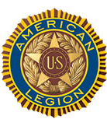
Post Meetings
- Member Meeting: Third Wednesday @ 5:30 p.m.
- Special Meeting: May be called by Commander, upon written request of 10 members in Good Standing.
- Web Page:
- Facebook Page:

A Short History

Our Post in Pacific Palisades, California was chartered by The American Legion on July 14, 1928, with 15 members. The original 1928 charter of our Post is framed and hangs on the wall in Ronald Reagan-Palisades, it lists the names of our charter members.
Our Post is over 695 members strong and growing. Our Post is an integral part of the Greater Los Angeles community and a proud advocate for veterans on the local, state, and national level. Our local membership extends throughout the county.

Legion Uniform What is the official uniform of The American Legion?
"A Legionnaire is in uniform if wearing an official American Legion Cap."
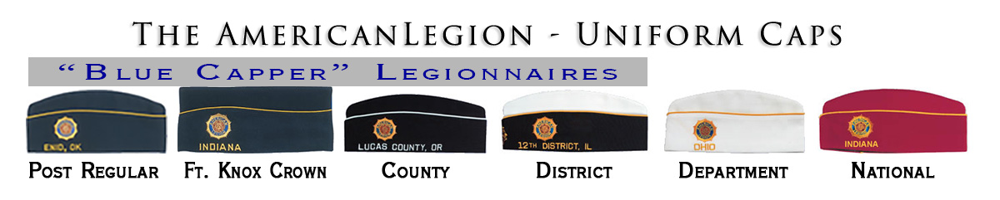
Why wearing your Legion Uniform in public is important? Legionnaires like us, seen in uniform doing the good work of The American Legion creates a positive image. This helps our community "see" The American Legion as an organization they want to support. It is a very important element of our public relations and marketing efforts.
There is no benefit to Legionnaires being invisible to the public as we do the good work of the Legion, so please expose yourself to the community as proud members of The American Legion, by wearing your uniform cap.

Legion Language and Protocols
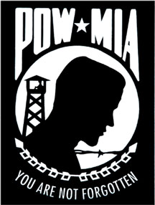
New Legionnaires often find the following information helpful:
- Meeting Conduct. Robert’s Rules of Order, Newly Revised, governs the conduct of Post meetings
- Ceremony Dignity. The ceremonial services of The American Legion are conducted with the solemnity befitting the dignity of this organization.
- POW/MIA Empty Chair. “A POW/MIA empty chair is placed at all official meetings of The American Legion as a physical symbol of the thousands of American POW/MIAs still unaccounted for from all wars and conflicts involving the United States of America."
- Gavel. A chair’s gavel is a symbol of authority & ensures orderly meetings.
- One tap is a message to the members:
  - To be seated following the opening ceremony
  - The completion of a business item, or
  - Following the announcement of adjournment
- Two taps of the gavel call the meeting to order.
- Three taps of the gavel are the signal for members to stand on the third tap.
- A series of sharp taps is used to restore order at a meeting.
- Silent Tribute. Legionnaires standing in silent tribute in memory of departed comrades during meetings or ceremonies will face the U.S. Flag with Legion cap or hand held over their heart.
- The Hand Clap. This long held Legion tradition is a slow and rhythmic clapping of hands, much like the slow beat of a drum. The hand clap is used to welcome new members and guests when they are brought forward to be introduced and when leaving the lectern. This demonstrates respect for the individual being recognized.
- PUFL stands for Paid-Up-For-Life membership.
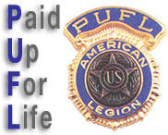
- Transferred to Post Everlasting - refers to a Legionnaire who has died and transferred to the Post Everlasting.
- Volunteers are Super! They are!
Your Volunteer Time Has Value: Volunteer time is now estimated to be worth over $24 per hour! Legionnaire volunteer time is even more valuable.
We are a Legion of super volunteers!

Training https://www.legion.org/training (NOTE: “Those vets who need assistance in navigating the web portals, please ask and we will be happy to assist you.”)
Effective training is important to the success of our Legion. Quality training improves our ability to succeed by improving member involvement and operational performance. Training also helps teach organizational values and identify future post leaders. Conversely, the lack of effective training can lead to losing our focus on success and can limit our operational performance.
Many who accept leadership roles in The American Legion are often self-motivated by a desire to serve others and seek out training because they want to become stronger, better-informed leaders. Here are a few currently available training vehicles, most Legionnaires find helpful.
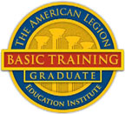
- “This is The American Legion” - is an excellent short video every member of our Legion Family should watch. This video is available on YouTube, at: https://www.youtube.com/watch?v=qfIQaYvsB8c
- Basic Training - is the new official training program of The American Legion for officers and members. To take the course, visit https://www.legion.org/alei
- Legion College - The American Legion National College enhances knowledge and appreciation of The American Legion. It teaches the core values and contributions of the organization, its Auxiliary, Sons of the American Legion and many subordinate programs. Visit https://www.legion.org/college
- Legion Publications - Legion publications can be an excellent training resource for those who are self-motivated. The Publications page of The American Legion web site is a good place to find most of them. Here are a few key publications you many find helpful. (https://www.legion.org/publications)
- https://www.calegion.org/resources.html
- Officer’s Guide and Manual of Ceremonies
- Post Operations Manual and Post Building Guide
- The American Legion Positions and Programs
- The American Legion Membership Public Relations Guide
- Why You Should Belong

Member Information (MyLegion.org)

Accurate and up-to-date member information is important for any organization. We are very fortunate in the American Legion that every member can take an active role in keeping their information accurate and up-to-date, using the myLegion.org members-only web portal.
This requires a Member Account be established in MyLegion.org. To establish the member account, visit the home page of The American Legion web site (legion.org) and click on the MYLEGION.ORG link at the very top of the home page.
Once your personal Member Account is established in MyLegion.org, select the "MY PROFILE" option to update your information or print a copy of your membership card.

In addition to updating your personal profile information you can also:
- Subscribe to electronic newsletters
- View past editions of the Legion Magazine
- Make donations in the "Giving Made Easy" option
- Find out about special offers available to Legionnaires, and
- Select dues renewal options
In the dues Renewal Options, we highly recommend the automatic payment option for annual dues. It is an easy and smart way to keep your dues current.
I want to setup automatic payments for future annual membership renewals.

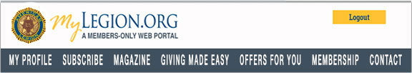

Post Governance
Our Post By-Laws state,
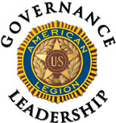
“The administration, governance and management of this Post is entrusted to the Executive Committee.”
Good post governance is an essential duty of post leaders and it includes a variety of elements. It is realized in the long-term success of our post.

Executive Committee - the administration, governance and management of Our Post is entrusted to the Executive Committee.
The Executive Committee consists of six members. Executive Committee membership is comprised of 2 elected members each year, in addition to the following officers of the Post: Commander, Adjutant, Finance Officer, First Vice-Commander, Second Vice-Commander, Third Vice-Commander, and Junior Past Commander.
Vision of Success:
“Our Post excels in service to fellow veterans, their families, and our community, while consistently operating as a model of quality post operations."

Key Post Goals:
- Sustained membership growth
- Financial solvency and stability
- Excellent leadership development
- Successful programs
- Quality service to veterans, their families and community
Mission Statement: “Our Post exists to support fellow veterans, their families, and our community.”
Constitution & By-Laws: The Constitution & By-Laws are two of the most important documents in our post operation. They define the complete responsibilities of all Post Officers and they are available from the Post Adjutant.

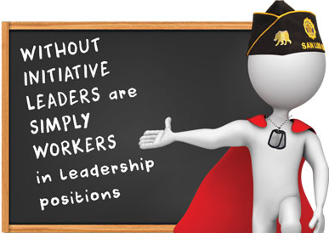
Post Leadership
In The American Legion and Our Post, leadership is provided by volunteer members, like you. Post leaders are fundamentally responsible for the success of Our Post. These volunteers serve in many different leadership roles as Post officers, committee members, chairmen and mentors to new members. Good Post leaders have the initiative to provide honorable and noteworthy service to our veterans, their families and the communities we serve.
Many believe leadership is not something you are born with and it cannot be awarded or appointed. True leadership for many, is something learned and earned through the hard work of service to others. Legion leaders must have stellar character and transparent integrity.
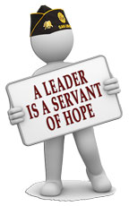
Good post leaders must give an adequate commitment of time, sufficient personal energy and must communicate effectively, to give our posts strong roots in the communities where we serve our veterans.
No Partisan Politics
The American Legion is a 501 (c) (19) non-profit corporation and is absolutely non-partisan. Policies, Not Partisan Politics is our guiding principle.

Summary Post Leader Duties
Post leaders are responsible for the post’s success. Our Post Constitution and By-Laws are the ultimate reference on post leader duties. The following descriptions are intended as a generic overview of what many consider key responsibilities of post leaders.
The Post Commander, Finance Officer and Adjutant, are “required” officers in the annual Certification of Eligibility of American Legion Post Officers. This is one of the forms our post must submit each year, to maintain our charter.
Post Commander (Elected) "First among equals." is a good way to look at the relationship of the Post Commander to other post members. The Commander ensures the post's vision of success is completed and keeps the post family together in the process. The Post Commander traditionally serves as the President of the Board of Directors for incorporated posts. The Post Commander is also the voice of the post, within the post and at meetings beyond the post. Post Commanders also work with and through other leaders to complete the post business, as they cultivate and guide them for future leadership roles.
Finance Officer (Elected) Much of the Post Finance Officer's work is defined and determined by standard accounting practices and the needs of the post. The Post Finance Officer is the person of integrity that helps develop a post budget and administers the post book of accounts. Finance Officers also advise post leaders on the formulating and administering of financial policies, including the annual Post budget.
Adjutant (Appointed) Whether seen as a Post ‘First Sergeant’ or a Continuity Officer, the Adjutant’s role is critical in the long-term success of our post. Adjutants are responsible for keeping official records of our post business, minutes of meetings and many key administrative compliance duties.
Executive Committee Members (Elected) The Executive Committee Members are advocates for the general membership, assist post officers in directing post business and act as post representatives in the absence of post officers.
First Vice-Commander (Elected) The American Legion "Officer's Guide" states this about the First Vice Commander, “is elected with membership as the primary concern”. The First Vice Commander is the designated liaison membership (i.e. coordinated recruitment, retention, member renewals and ensuring the post routinely has personal contact with every member of the post), and shall perform such other duties as directed by the Post.

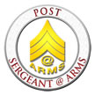
Second Vice-Commander (Elected), the Second Vice Commander is the designated liaison to other veteran organizations, coordinates new member orientation and shall oversee Post morale to include entertainment and special programs, and other duties as directed by the Post.
Third Vice-Commander (Elected), The Third Vice Commander is the designated liaison to all the Post’s Committee, to insure that the Committees are meeting, and other duties as directed by the Post.
Sgt-at-Arms (Appointed) shall preserve order at all meetings, ensures members are properly greeted at the door, makes new members welcome, and oversees flag etiquette/disposal, and shall perform such other duties as may be assigned by the Post. Often the first of four steps in the journey to becoming Post Commander.

Post Operating Committees
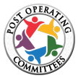
To help advise the Commander and Executive Committee. The Post may establish and define the work of Post committees.
With the Commander’s consent, each chairperson selects at least two other members to serve on each committee and they will serve for an indefinite term at the discretion of the chairperson.
Through work on committees, our members provide the hard work needed for our Post’s success as they plan, organize, communicate and implement the programs of our Post and The American Legion.
The Post Operating Committees are critical to increasing active membership. Committees within Our Post create a forum for members to pursue personal interests. They allow for the strengths and dedication of our members to shine. Post members, like you, serving on committees can grow as productive post members and leaders. Committee work also functions as a very important training ground to develop the leadership skills and knowledge of the Legion future Post leaders need to succeed.

Committee Descriptions
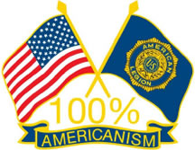
Americanism Committee(s) - seeks to inspire love of country and good citizenship through patriotic observances, flag etiquette, civic instruction in schools, community service, and youth activities such as Boys State, Boy Scouts, Oratorical Contest and School Award Medals.
Membership Committee - has charge of all matters pertaining to membership eligibility, growth, acceptance, retention, and renewals. Guidance is provided by the First Vice Commander.
Finance Committee - supervises the financial duties of the Post, prepare the annual budget and advise the Executive Committee on financial matters.
Ways & Means Committee - develops fund-raising projects to support post programs. Once approved they are responsible for the project’s completion and success.
The Dynamic Pay tool is currently our primary fundraiser.
Our Legion Family and friends of our Post give their financial support to this important event to help fund The American Legion programs we conduct.
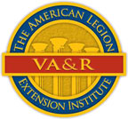
Veterans Affairs & Rehabilitation (VA&R) Committee -
is responsible for bringing to the attention of members and their dependents the rights and benefits granted them by law. They shall assist veterans in the pursuance of claims and in obtaining other veteran’s rights and benefits; to visit comrades who are sick or disabled; to visit and comfort members of their families of sick or bereaved.
Medias & Communications Committee - oversees print and digital media communications and channels delivered from our Post. The committee also has oversight of Our Post’s media outreach program. It also provides support for key marketing initiatives of Our Post.
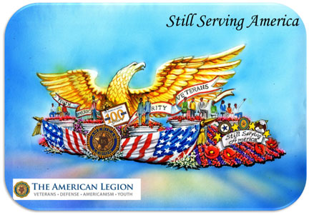

Although the Preamble of The American Legion Constitution is printed on the back of our membership cards, having it available in larger text, is helpful to many Legionnaires. We recite the Preamble before each meeting, as it is the written essence of who we are.

The Preamble:
For God and Country, we associate ourselves together for the following purposes:
To uphold and defend the Constitution of the United States of America;
To maintain law and order;
To foster and perpetuate a one hundred percent Americanism;
To preserve the memories and incidents of our associations in all Great Wars;
To inculcate a sense of individual obligation to the community, state and nation;
To combat the autocracy of both the classes and the masses;
To make right the master of might;
To promote peace and goodwill on earth;
To safeguard and transmit to posterity the principles of justice,
freedom and democracy;
To consecrate and sanctify our comradeship by our devotion to
mutual helpfulness.

Our Post Meeting Address:
Ronald Reagan-Palisades Post 283
15247 La Cruz Drive
Phone: (310) 454-0527
Mailing Address:
American Legion Post 283
P. O. Box 283, Pacific Palisades, CA 90272-283

